23OMG971 TOTAL QUALITY MANAGEMENT

UNIT I INTRODUCTION
Introduction - Need for quality - Evolution of quality - Definition of quality - Dimensions of product and service quality –Definition of TQM-- Basic concepts of TQM - Gurus of TQM (Brief introduction) -- TQM Framework- Barriers to TQM –Benefits of
TQM..
UNIT II TQM PRINCIPLES
Leadership - Deming Philosophy, Quality Council, Quality statements and Strategic planningCustomer Satisfaction – Customer Perception of Quality, Feedback, Customer complaints, Service Quality, Kano Model and Customer retention – Employee involvement – Motivation, Empowerment, Team and Teamwork, Recognition & Reward and Performance Appraisal-- Continuous process improvement –Juran Trilogy, PDSA cycle, 5S and Kaizen- Supplier partnership – Partnering, Supplier selection, Supplier Rating and Relationship development

UNIT-III TQM TOOLS & TECHNIQUES

The seven traditional tools of quality - New management tools -Six-sigma Process Capability Bench marking - Reasons to benchmark, Benchmarking process, What to Bench Mark, Understanding Current Performance, Planning, Studying Others, Learning from the data, Using the findings, Pitfalls and Criticisms of Benchmarking - FMEA - Intent , Documentation, Stages: Design FMEA and Process FMEA.

UNIT IV TQM TOOLS & TECHNIQUES II
Quality circles – Quality Function Deployment (QFD) - Taguchi quality loss function – TPM – Concepts, improvement needs –Performance measures- Cost of Quality - BPR.

UNIT V QUALITY MANAGEMENT SYSTEM

Introduction-Benefits of ISO Registration-ISO 9000 Series of Standards-Sector-Specific Standards - AS 9100, TS16949 and TL 9000-- ISO 9001 Requirements-Implementation-Documentation-Internal Audits-Registration-Environmental Management System: Introduction—ISO 14000 Series Standards—Concepts of ISO 14001—Requirements of ISO 14001-Benefits of EMS.

TEXT BOOK:
- Dale H.Besterfiled, Carol B.Michna, Glen H. Bester field,MaryB.Sacre, Hemant Urdhwareshe and Rashmi Urdhwareshe, “Total Quality Management”, Pearson Education Asia, Third Edition, Indian Reprint,Sixth Impression,2013

REFERENCES:
- Joel.E. Ross, “Total Quality Management – Text and Cases”, Routledge., 2017.
- .Kiran.D.R, “Total Quality Management: Key concepts and case studies, Butterworth – Heinemann Ltd, 2016.
3.Oakland, J.S. “TQM – Text with Cases”, Butterworth – Heinemann Ltd., Oxford, 3rd Edition, 2003.
4.Suganthi,L and Anand Samuel, “Total Quality Management”, Prentice Hall (India) Pvt. Ltd.,2006.

UNIT I – INTRODUCTION

TQM is defined as both philosophy and a set of guiding principles that represent the foundation of continuously improving organisation. It is the application of quantitative methods and human resources to improve all the process within the organisation and exceed customer needs now and in the future.

Definition of quality

Total Quality Management (TQM) refers to management methods used to enhance quality and productivity in business organizations. TQM is a comprehensive management approach that works horizontally across an organization, involving all departments and employees and extending backward and forward to include both suppliers and clients/customers. Total Quality Management (TQM) refers to management methods used to enhance quality and productivity in business organizations. TQM is a comprehensive management approach that works horizontally across an organization, involving all departments and employees and extending backward and forward to include both suppliers and clients/customers. Total Quality Management (TQM) refers to management methods used to enhance quality and productivity in business organizations. TQM is a comprehensive management approach that works horizontally across an organization, involving all departments and employees and extending backward and forward to include both suppliers and clients/customers.
One of the important issues that business has focused on in the last two decades is quality. The other issues are cost and delivery. Quality has been widely considered as a key element for success in business in the present competitive market. Quality refers to meeting the needs and expectations of customers. It is important to understand that quality
is about more than a product simply working properly.

Quality refers to certain standards and the ways and means by which those standards are achieved, maintained and improved. Quality is not just confined to products and services. It is a homogeneous element of any aspect of doing things with high degree of perfection. For example Business success depends on the quality decision making.

EVOLUTION OF QUALITY

Time Until 1960s | Events
Prior to the 20th century | Quality is an art
Prior to the 20th century | Demands overcome potential production
Prior to the 20th century | An era of workmanship
F.Taylor 1900s | The scientific approach to management
F.Taylor 1900s | resulting in rationalization of work and its
F.Taylor 1900s | break down leads to greater need for

 | standardization, inspection and
 | supervision
Shewart 1930s | Statistical beginnings and study of quality
Shewart 1930s | control. In parallel, studies by R A Fisher
Shewart 1930s | on experimental design; the beginning of
Shewart 1930s | control charts at western Electric in USA
Late 1930s | Quality standards and approaches are
Late 1930s | introduced in France and Japan.
Late 1930s | Beginning of SQC, reliability and
Late 1930s | maintenance engineering
1942 | Seminal work by Deming at the ministry
1942 | of war in USA on quality control and
1942 | sampling
1942 | Working group setup by Juran and Dodge
1942 | on SQC in US army
1942 | Concepts of acceptance sampling devised
1944 | Daodge and Deming carried out seminal
1944 | research on acceptance sampling
1945 | Founding of the Japan standard
1945 | association
1946 | Founding of the ASQC
1950 | Visit of Deming in Japan at the invitation
1950 | of K Ishikawa
1951 | Quality assurance increasingly accepted
1954 | TQC in Japan ; Book published 1956
1957 | Founding of European organization for the
1957 | control of quality
After 1960s
1961 | The Martin Co in USA introduces the zero
1961 | defects approach while developing and
1961 | producing Pershing Missiles. Quality
1961 | motivation is starting in the US and
1961 | integrated programmes begun
1962 | Quality circles are started in Japan

Define Quality .

  - Predictable degree of uniformity and dependability at low cost and suited to the market -Deming
  - Fitness for use-Juran
  - Conformance to requirements - Crosby

  - Minimum loss imparted by a product to society from the time the product is shipped - Taguchi
  - A way of managing tile organization -Feigenbaum
  - Correcting and preventing loss, not living with loss - Hosffin .

  - The totality of characteristics of an entity that bear on its ability to satisfy stated and implied needs – ISO
QUANITIFICATION OF QUALITY
Q= P / E

P = Performance E = Expectations Q = Quality

DIMENSION OF QUALITY

Quality has 2 dimensions. These dimensions are product and service quality.

Dimensions of product quality:

- Performance: primary product characteristics, e.g. picture brightness in TV.
- Features: secondary characteristics, added features, e.g. remote control, picture-in-picture.
- Usability: ease of use with minimum training.

- Conformance: meeting specifications, industry standards,. (E.g. ISI specs., emission norms)
- Reliability: consistency of performance over a specified time period under specified conditions.
- Durability: extent of useful life, sturdiness.
- Maintainability/Serviceability: ease of attending to maintenance, repairs.
- Efficiency: ratio of output to input. E.g. mileage, braking distance, processing time.

- Aesthetics: sensory characteristics, e.g. appearance, exterior finish, texture, color, shape, etc.

- Reputation: subjective assessment based of past performance, brand image, industry ranking.
- Safety: in items like pressure cookers, electrical items, toys, cranes, etc.

Dimensions of service quality:
  - Time: how much time a customer must wait / undergo service.
  - Timeliness: whether service will be performed when promised.
  - Completeness: whether all items in the order are included.

  - Consistency: consistent service every time, and for every customer. Reliability of service.
  - Accessibility/Convenience: ease of obtaining the service.
  - Accuracy: absence of mistakes.
  - Responsiveness: quick response, resolution of unexpected problems.
  - Courtesy: cheerful, friendly service.
  - Competency/Expertise: In professions like doctors, lawyers, mechanics, etc.

DIMENSION OF QUALITY
Product quality | Service quality
Performance | Time
Features | Timeliness
Usability | Completeness
Conformance | Consistency
Reliability | Accessibility/Convenience
Durability | Accuracy
Maintainability/Serviceability | Responsiveness
Efficiency | Courtesy
Aesthetics | Competency/Expertise
Reputation
Safety

TQM BASIC CONCEPTS

- Management Involvement – Participate in quality program, develop quality council, direct participation

- Focus on customer – who is the customer – internal and external, voice of the customer, do it right first time and every time.
- Involvement and utilization of entire work force – All levels of management

- Continuous improvement – Quality never stops, placing orders, bill errors, delivery, minimize wastage and scrap etc.
- Treating suppliers as partners – no business exists without suppliers.
- Performance measures – creating accountability in all levels

TQM DEFINITION

- TQM is the management approach of an organization, centered on quality, based on me participation of all its members and aiming at long-term success through customer satisfaction. and benefits to all members of me organization and to society.- ISO

- TQM is an integrated organizational approach in delighting customers (both internal and external) by meeting their expectations on a continuous basis through everyone involved with

the organization working on continuous improvement in all products, services, and processes along with proper problem solving methodology.

- TQM is people - focused management system that aims at continual increase in customer satisfaction at continually lower cost. TQM is a total system approach (not a separate area of program), and an integral part of high level strategy. It works horizontally across functions and departments, involving all employees, top to bottom, and exceeds backwards and forward to include the supply chain and the customer chain.

TQM Framework
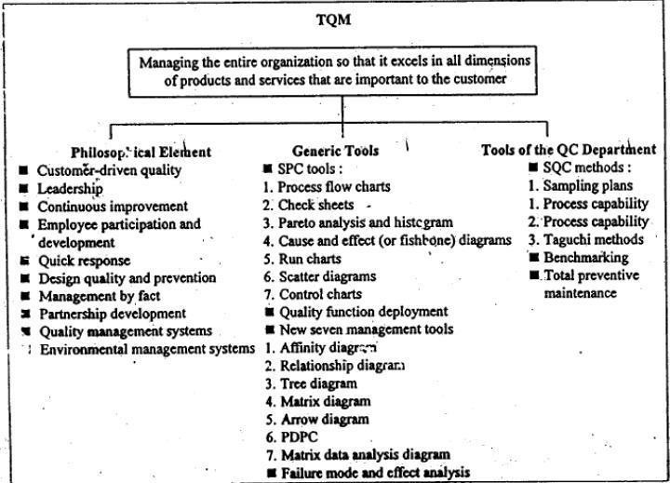
Contributions of Deming, Juran and Crosby

Deming’s 14 points for Management:
  - Create and publicize to all employees the aims and purposes of the organization.
  - Adopt the new philosophy (of customer satisfaction, continuous improvement, defect prevention, management-labour cooperation, etc.).
  - Stop dependence on inspection to achieve quality. (Managers must understand how variation affects their processes and take steps to reduce the causes of variation. Workers must take responsibility for their own work).
  - End the practice of awarding business on the basis of price tag alone. (Costs due to inferior materials/components increase costs in the later stages of production. Suppliers themselves are part of the whole system and hence should be treated as long-term partners).

  - Improve constantly and forever the system of production and service .(Aim for small, incremental, continuous improvements – not merely in the area of production but also covering transportation, maintenance, sales, service, administration, etc. – all areas of the organization).
  - Institute training. (Employees need the proper tools and knowledge to do a good job, and it is management’s responsibility to provide these. Training not only improves quality and productivity, but also enhances workers’ morale).
  - Adopt modern methods of supervision and leadership. (Managers, Supervisors should act as coaches, facilitators and not as policemen).
  - Drive out fear. (Fear in work manifests as fear of reprisal, fear of failure, fear of change, fear of the unknown. Fear encourages short-term, selfish thinking, not long-term improvement for the benefit of all).
  - Break down barriers between departments and individuals. (Promote teamwork).
  - Eliminate the use of slogans and exhortations. (Workers cannot improve solely through motivational methods when the system in which they work constrains their performance. On the contrary, they will become frustrated, and their performance will decrease further).
  - Eliminate work standards, numerical quotas, and MBO. (Numerical quotas reflect short-term perspectives and do not encourage long-term improvement. Workers may shortcut quality to reach the goal. The typical MBO system focuses on results, not processes, and encourages short-term behavior).
  - Remove barriers to pride in workmanship. (Treating workers as commodities; giving them monotonous jobs, inferior tools; performance appraisals, management assuming it is smarter than workers and not using the workers’ knowledge and experience to the fullest extent).
  - Encourage education and self-improvement for everyone.
  - Take action to achieve the transformation. (The TQ philosophy is a major cultural change,and many firms find it difficult. Top management must take the initiative and include everyone in it).

Contributions of Juran to TQM. Biographical:
- Joseph M. Juran, Ph.D. (1904- ). Born in Romania. His parents migrated to the USA.
- Worked at Western Electric Co.from 1924 to 1941. There he got exposed to the concepts of Shewhart.

Contributions:
- In 1951, he published ‘Quality Control Handbook’ which is still a standard reference for quality control departments in organizations.
- Traveled to Japan in 1954 to teach quality management to the Japanese at the invitation of the Japanese Union of Scientists and Engineers (JUSE). Juran and Deming introduced the concept of SQC to the Japanese. Helped the Japanese to improve quality to unprecedented levels.
- He popularized the concept of Fitness for Quality – comprising of Quality of Design, Quality of Conformance, Availability (reliability), Safety and Field Service.
- Along with Deming, he introduced the concept of ‘Quality Assurance’.
- He formulated a Quality Planning Roadmap.

Quality Planning Roadmap.
- Identify your customers,
- Find out their needs,
- Translate them into technical requirements,
- Develop the product,
- Develop and validate the process,
- Translate the resulting plan to the operating personnel.
  - He advocated the accounting and analysis of quality costs to focus attention on quality problems.
  - He emphasized that upper management in particular needed training and experience in managing for quality. At the operational level, his focus was on increasing conformance to specifications through the elimination of defects, supported by statistical analysis.
  - Founded Juran Institute in 1979 to provide training, consulting services for improving business performance and attaining quality leadership.
  - His book ‘Managerial Breakthrough’ (1964) presented the concept of ‘Universal Breakthrough Sequence (or Breakthrough improvement), which has now evolved into Six Sigma, the basis for quality initiatives worldwide.
  - Juran described quality from the customer perspective as having two aspects: Higher quality means a greater number of features that meet customers’ needs. Freedom from trouble’ – higher quality consists of fewer defects.
  - Juran is recognized as the person who added the human dimension to quality – broadening it from its statistical origins, and thus helping develop the concept of TQM.

BARRIERS IN TQM IMPLEMENTATION

Many organizations, especially small ones with niche products, are comfortable with their current state. They are satisfied with their current level of performance and profits. Organizations with this culture will see little need for TQM until they begin to lose market share.
Awareness comes about when (a) the organization loses market share or (b) TQM is mandated by the customer, or (c) management realizes that TQM is a better way to run a business and compete in domestic and world markets.
Once an organization embarks on TQM, the following are some of the major obstacles encountered in implementation:
- Lack of management commitment: Management does not allocate sufficient time and resources for TQM implementation. The purpose is not clearly, consistently communicated to all personnel. Management’s compensation is not linked to quality goals such as failure costs, customer complaints, and cycle time reduction.
- Inability to change organizational culture: Even individuals resist change; changing an organization’s culture is much more difficult and may require as much as 5 years or more. Exhortations, speeches, slogans are effective only in the short run.
- Improper planning: Absence of two-way communication of ideas during the development of the plan and its implementation.
- Lack of continuous training and education.
- Inadequate use of empowerment and teamwork.
- Lack of employee involvement.
- Non-cooperation of first-line managers and middle management.
- Lack of clarity in vision.
- Emphasis on short-term results.

- Setting of unmanageable, unrealistic goals.
- Bureaucratic system.
- TQM is considered as a quick-fix solution to current problems.
- Treating suppliers as adversaries to be manipulated, taken advantage of Adversarial relationship between workers/unions and management. Motivating employees through fear of punishment.
- Failure to continually improve. Tendency to sit back and rest on one’s laurels. Rigidly sticking to one ‘success formula’. Lack of access to data and results. Paying inadequate attention to internal and external customers. Ineffective measurement techniques for key characteristics of the organization. Inability to understand the changing needs and expectations of customers. Absence of effective feedback mechanism.

THE CUSTOMERS
    - The most important people in the business
    - Not dependent on the organization, but the organization depends on them.
    - Not an interruption to work but are the purpose of it.
    - Doing a favor when they seek business and not vice-versa.
    - A part of business, not outsiders and they are life blood of the business
    - People who come with their needs and jobs
    - Deserve the most courteous and attentive treatment.

TYPES OF CUSTOMERS
Internal Customer: The customer inside the company are called internal customers
External Customers: An external customer is the one who used the product or service or who purchase the products or service or who influences the sale of the product or service.

CUSTOMER SATISFACTION

The Customer is the King - Emphasized by Today's Buyers Market. TQM's Purpose is meeting or exceeding customer expectations, so that the customers are delighted. The customer satisfactions must be the primary goal of any organization.

Customer satisfaction model
Teboul‘s Model of customer satisfaction as shown in figure
From the above diagram it is understood that the company should strive for increasing the intersection portion i.e. Customer Satisfaction.
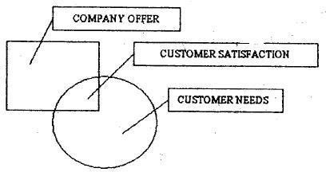

CUSTOMER COMPLAINTS (FEEDBACK)

Customer feedback must be continuously solicited and monitored to reduce the unsatisfied customers as much as possible.

CUSTOMER FEEDBACK OR CUSTOMER COMPLAINT IS REQUIRED

- To discover customer dissatisfaction
- To identify customer‘s needs

- To discover relative priorities of quality
- To compare performance with the competition
- To determine opportunities, for improvement

TOOLS USED FOR COLLECTING CUSTOMER COMPLAINTS
  - Comment card - Low cost method, usually attached to warranty card
  - Questionnaire - Popular tool, costly and time consuming - by mail or telephone preferably multiple choice questions or a point rating system (1 to 5) or (1 to 10)
  - Customer Focus groups - Meeting by a representative of the company with the group of customers. Imprint analysis is an emerging technique to obtain intrinsic feelings using customer meetings, word associations, discussion, relaxation techniques etc.
  - Phone - Toll free Telephone numbers
  - Customer visits - Visit customer's place of business.
  - Report cards - Usually, send to customer on a quarterly basis.
  - The internet and computer - It includes newsgroups, electronic bulletin board mailing lists,
  - Employee feedback.
  - Mass Customization - Capturing the voice of customers using data of what customer want instead of what customer is thinking about buying and manufacturing exact what they want.

SOLVE CUSTOMER COMPLAINTS

- Complaints can be collected from all sources (letters, phone -calls, meetings and verb inputs)
- Develop procedures for complaint resolution, that include empowering front-line personnel.
- Analyze complaints, but understand that complaints do not always fit into new categories Work to identify process and material variations and then eliminate the root cause.
- When a survey response is received, a senior manager should contact the customer and strive to resolve the concern.
- Establish customer satisfaction measures and constantly monitor them.
- Communicate complaint information, as well as the result of all investigation solution, to all people in the organization. .
- Provide a monthly complaint report to the quality council for their evaluation and needed, the assignment of process improvement teams.
- Identify customer's expectations beforehand rather than afterward through complaint analysis.

CUSTOMER RETENTION.

- More powerful and effective than customer satisfaction It is the process of retaining the existing customer
- Customer care can be defined as every activity which occurs within the organization that ensures that the customer is not only satisfied but also retained.

SIGNIFICANCE OF CUSTOMER RETENTION
- 60% of organizations future revenue will come from existing customers
- 2% increase in customer retention has 10% decreases in operating cost.
- 96% of unhappy customers do not complain but 3 times likely to convey to other customers about their bad experience.
- 91% of unhappy customers never purchase goods and services from you.
- It costs 5 times more to attract the customer than retaining the existing customer.
- Customer retention creates customer loyalty and moves customer satisfaction to a next level called customer delight.

UNIT II TQM PRINCIPLES
LEADERSHIP
The process of influencing others towards the accomplishment of goals. He triggers tile will to do, shows the direction and guide the group members towards the accomplishment

CHARACTERISTICS OF QUALITY LEADERS

- Customers first

- Value people

- Build suppler partnership

- Empower people

- Strive for excellence

- Demonstrate involvement / commitment

- Explain & deploy policy

- Improve communication

- Promote teamwork

- Benchmark continuously

- Establish system

- Encourage collaboration

LEADERSHIP ROLES

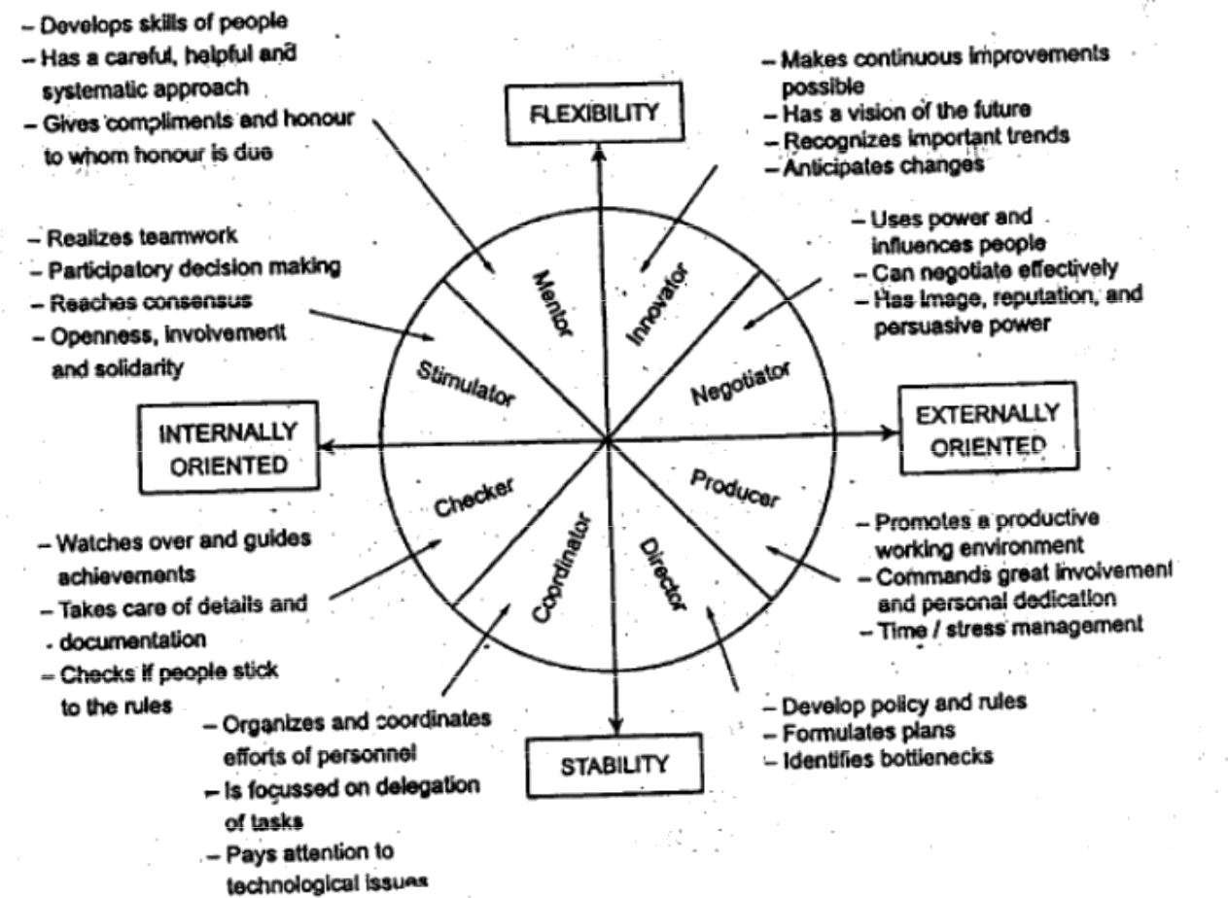

ROLE OF SENIOR MANAGEMENT

- Study and investigate TQM concepts and issues
- Set clear quality policies and provide challenging tasks

- Establish customer satisfaction as a long term goal

- To become coaches and cheer leaders for encouraging and supporting the managers during transition phase of the transformation

- To stimulate employees to be involved
- To attend TQM training programs

- To up hold norms and issues

- To create a basic of trust, respect and open communication that ensures individual participation and continuous improvement.

- To monitor whether quality improvement programs are conducted as planned.

STRATEGIC QUALITY PLANNING

It sets the long term direction of the organization in which it wants to proceed in future. Can be defined "As the process of deciding on objectives of the organization, on changes on this objective,

on the resource used to obtain these objectives and on the policies that are to govern the acquisition use and disposition of these resources"
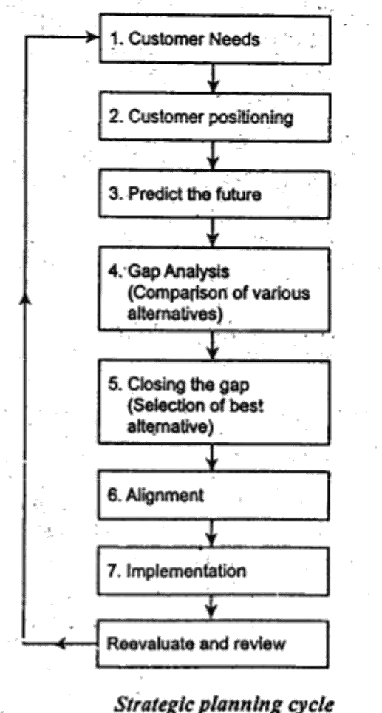

Quality statements

VISION STATEMENT: It is a short declaration of what an organization aspires to be tomorrow. It is an ideal state which may never be achieved.

Example: To continuously enrich knowledge base of practioners in mobility industry and institutions in the service of humanity - SAE

MISSION STATEMENT: Describes the function of the organization. It provides the clear statement of purpose for the employees, customers and suppliers.
Example: “Facilitating world class technical education through high quality institutions, academic excellence and innovative research and development programmes, technology forecasting and global manpower planning, promoting industry institute interaction, inculcating entrepreneurship - AICTE
QUALITY POLICY STATEMENT: It is a guide for everyone in the organization as to how they provide products and services to the customer. Written by the CEO feedback from workforce and approved by quality council.

Example: Xerox is a quality company. Quality is the basic business principle for Xerox. Quality means providing our external and internal customers with innovative products and service that fully satisfy their requirements. Quality is the job of every employee – Xerox Corporation

EMPLOYEE INVOLVEMENT
It is the total involvement from every person at all levels in the organization ASPECTS OF EMPLOYEE INVOLVEMENT
- Employee motivation
- Employee Empowerment
- Teams and Team work
- Recognition and Reward Schemes
- Performance Appraisal

EMPLOYEE MOTIVATION

It is the process of stimulating people or attempting to influence other to do your will or accomplish desire goals through the possibility of reward
  - Improves employee involvement
  - Reduces absenteeism and increases turn over
  - Promotes job satisfaction

THEORIES OF MOTIVATION

Maslow’s Hierarchy of needs

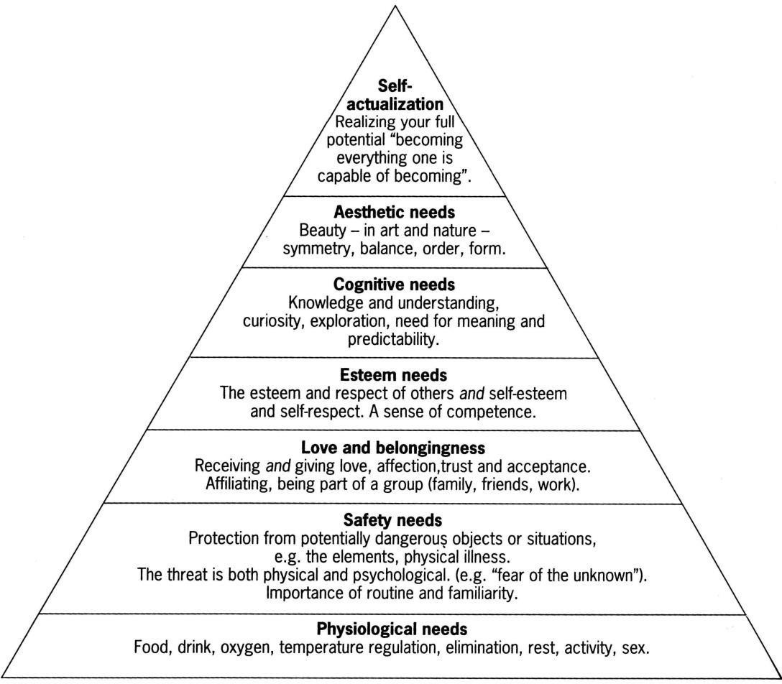

HERZBERG’S TWO FACTOR THEORY

- Motivation Factor: People are motivated by recognition, responsibility, achievement, advancement and the work itself. These are called as motivators
- Dissatisfies or Hygiene Factor: Low salary, minimal fringe benefits, poor working conditions, ill defined organizational policy, mediocre technical supervision are dissatisfies which implies they are preventable.

EMPLOYEE WANTS
- Good pay factor is normally in the middle of ranking.
- Normal Wants are interesting work, appreciation, involvement job security, Good pay, Promotion/growth, Good working conditions, Loyalty to employees, Help with personal problems arid Tactful Discipline.

EMPLOYEE EMPOWERMENT.
It is an environment in which people have the ability, the confidence and the commitment to take his responsibility and ownership to improve the process and initiate the necessary steps to satisfy customer requirements within well-defined boundaries in order to achieve organizational values and goals.
Job Enrichment: Is expanding content of the Job.
Job Empowerment: Is expanding the context of the job.

GENERAL PRINCIPLES OR CHARACTERISTICS FOR' EMPOWERING EMPLOYEES

- Tell people what their responsibilities are.
- Given the authority equal to the responsibility assigned to them.
- Set standards of excellence.
- Give them knowledge information and feedback.
- Trust them and treat them with dignity and respect.

, ,
CONDITIONS TO CREATE THE EMPOWERED ENVIRONMENT

- Everyone should understand the need to change
- The system need to change to new paradigm.
- The organization must provide information, education, and skill to its employees.

TEAMS AND TEAM WORKS
A team can be defined as a group of people working together to achieve common objectives or goals Team work is the cumulative actions of the team during which each member of the team subordinates his individual interest and opinions for the fulfilling of objectives of the group.

TYPES OF TEAMS

Process improvement team: Involved in improvement of sub processes or processes. Usually has 6-10 members. Disbanded when the objective is reached. May include the local supplied and customer depending on the location

Cross functional teams: 6-10 members temporary team. Members are Top management level from various functional areas of management. Discuss complex problems and break down into smaller parts to refer it to various departmental teams for further solution.

Natural work teams: Not voluntary and the total work unit is part of the team. Manager also a part of the team and the management selects the projects to be improved. Managers must also ensure that the entire team is comfortable with each other.

Self directed / self managed work team: Extension of natural work teams but here the group of individuals is empowered not only to do work but manage it. No manger will present but a coordinator (Which will be normally rotated among members) will be appointed. Additional responsibilities of the team hiring/ dismissal, performance evaluation, customer relations, supplier relations, recognition/rewards and training.

CHARACTERISTICS OF SUCCESSFUL TEAMS

- Sponsor: In order to have effective liaison with quality council, there should be sponsor. The sponsor is a person from the quality council, he is to provide support to the organization
- Team Charter: A team charter is a document that defines the team‘s mission boundaries, the background of the problem, the team‘s authority and duties and resources. It also identifies the members and their assigned roles – leader, recorder, time keeper and facilitator.

- Team Composition: Not exceeding 10 members except natural work team and self managed teams.
- Training: The team members should be trained in the problem solving techniques team dynamics and communication skills
- Ground Rules: The team should have separate rules of operation and conduct. Ground rules should be discussed with the members, whenever needed it should be reviewed and revised
- Clear objectives, Accountability : Periodic status report should be submitted to quality council for review
- Well defined decision procedure, Resources: Adequate information should be provided
- Trust by the management, Effective problems solving: Not by hunches or quick fires
- Open communication, Appropriate Leadership, Balanced participation and Cohesiveness

ELEMENTS OF EFFECTIVE TEAM WORK
Regular scheduling with a fixed time limit, purpose, role and responsibilities, activities, decision, results and recognition.

TEAM MANAGEMENT WHEEL
To make a lean more effective a team management wheel has been evolved. The activities are advising, innovating, promoting, developing, organization, producing, inspecting, maintaining and linking. The roles of wheel are advisor, explore, organizer and controller.

STAGES OF TEAM DEVELOPMENT
  - Forming stage- Initial stage with only group of individuals and no team work. Team purpose, roles are created.
  - Storming Stage -Initial agreement roles are challenged. Hostilities, emerge which may be resolved
  - Norming Stage-Formal informal relations get established.
  - Performing Stage -Team operates in a successful manner with trust, openness, healthy conflict and decisiveness among the members.
  - Maintenance stage – Functioning should not deteriorate with time Evaluating Stage – Evaluating team performance

RECOGNITION AND REWARD.

Recognition is a process whereby management shows acknowledgement (Verbal or written) of an employee outstanding performance. Recognition is a form of employee +ve motivation. Reward is a tangible one such as increased salaries, commission, cash bonus, gain sharing etc., to promote desirable behavior. It can be even theatre tickets, dinner for two, a small cash awards, etc., The employees are recognized to improve their morale, show the company's appreciation for Better Performance, create satisfied and motivated workplace and stimulate creative efforts.

INTRINSIC VS EXTRINSIC REWARDS
INTRINSIC REWARDS | EXTRINSIC REWARDS
Related to feeling of accomplishment or self | Related to pay or compensation issues
worth
1. Non monetary forms of recognition to | 1. | Profit sharing
acknowledge achievement of quality | 2. | Gain sharing
improvement goals | 3. | Employment security
2. Celebrations to acknowledge achievement | 4. | Compensation time
of quality improvement goals | 5. Individual based performance systems

3. Regular expression of appreciation by | 6. Quality based performance appraisals
managers and leaders to employees to | 6. Quality based performance appraisals
acknowledge achievement of quality | 6. Quality based performance appraisals
improvement goals  - 360o performance appraisals feedback from co-workers, subordinates or customers is incorporated into performance appraisal  - Formal suggestion system available for individuals to make quality improvementsuggestion  - Developmental based performance appraisals  - Quality based promotion | 6. Quality based performance appraisals

STEVE SMITH’S TWENTY DIFFERENT WAYS TO RECOGNIZE THE EMPLOYEES

    - Send thank letter whenever possible
    - Develop behind the scenes award
    - Create the best ideas of the year booklet
    - Feature the quality team of the month and put their picture in prominent place
    - Honor peers by recognizing them
    - Allow people to attend meetings in your name when you are not available
    - Involve teams with external customers and suppliers by visiting them
    - Invite a team for coffee or lunch whenever possible
    - Create a visibility will displaying posters, pictures, to thank the contributions of employee
    - Credit the team to higher authorities when their ideas are accepted
    - Take interest in employee‘s development
    - Get the team picture in company newspaper
    - Mention the ideas of others during your meetings, so that they are recognized
    - Write a letter of praise to contributed team member and copy to boss
    - Ask people to help you with the project which is difficult but challenging
    - Send a team to special seminars, workshops to cover topics they are really interested in
    - Ask your boss to send a letter of acknowledgement and thanks
    - Honor outstanding contribution with awards
    - Have a stock of small gifts to give to people on the spot whom you catch doing things right
    - Promote or nominate for promotion, those people who contribute most

PERFORMANCE APPRAISAL.

It is a systematic and objective assessment or evaluation of performance and contribution of individual
Needs Identifying employees for salary revision, promotion, transfer, demotion, lay off To determine training needs of employee To take organizational inventory of people To know personal strength and weakness of individuals To validate the selection procedure

APPRAISAL FORMATS

Ranking (From highest to lowest), Narrative (Telling strength and weakness), Graphics (Graphical display of duties by rating), Forced choice (Placing each employee with a predetermined % like Good 25%, Poor 10% etc) Performance appraisal.
It is a systematic and objective assessment or evaluation of performance and contribution of individual
Needs Identifying employees for salary revision, promotion, transfer, demotion, lay off To determine training needs of employee To take organizational inventory of people To know personal strength and weakness of individuals To validate the selection procedure

APPRAISAL PROCESS

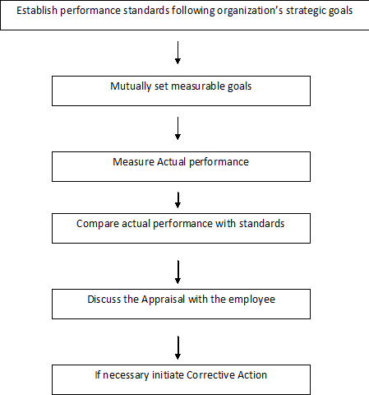

BENEFITS OF PERFORMANCE APPRAISAL
- Provides a feedback to identify employees for salary revision, transfer, lay-off
- Helps in determining training needs of employee
- Provides organization inventory of people

- Helps to evaluate personal strength and weakness of individuals
- To validate the selection procedure.
- Provide the basis for promotion, demotion etc
- May provide some information on external factors like family circumstances, health, financial or personal matters that may be affecting the performance

CONTINUOUS PROCESS IMPROVEMENT (CPI)

  - TQM has been defined as a philosophy based on quest for progress and continual improvement in the areas of cost, reliability, quality, innovation, efficiency and business effectiveness
  - It is a continuous learning process which never stops and is cyclic and iterative
  - To do CPI, we have different approaches such as Juran Trilogy, PDSA cycle, Kaizen and 5S concept

INPUT / OUTPUT PROCESS MODEL

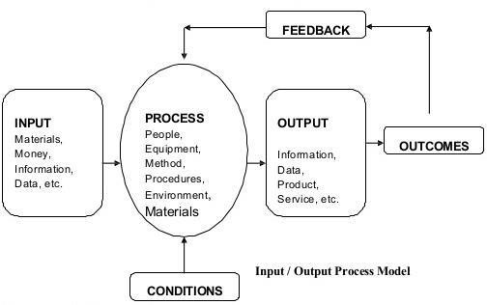
The process refers to business and production activities of an organization. Example Purchasing, Engineering, Marketing and Accounting

PDSA CYCLE
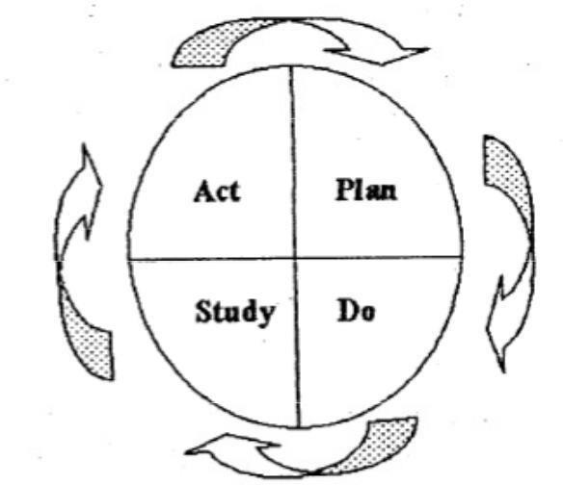

It is also called as Deming Cycle or Deming Wheel. Developed by Walter A. Shewart and popularized by Edward Deming

PLAN
- Identify the problem, plan and opportunities
- Observe and analyze
- Isolate the real causes
- Determine corrective actions

DO
- Prepare
- Apply
- Check application

STUDY / CHECK
- Check results
- Compare with goals

ACT
- Standardize and consolidate
- Prepare next stage of planning

BENEFITS OF PDSA CYCLE
- Daily routine management for the individual and or the team
- Problem solving process
- Project management
- Continuous development
- Vendor development
- Human resource management
- New product development
- Process trials

5S HOUSE KEEPING

This is a house keeping technique used to establish and maintain a productive and quality environment in an organization. This method is invented in Japan which will give safer, more efficient and more productive operation results in boosting of morale of workers, job involvement and satisfaction and ownership of their responsibilities.

JAPANESE TERM | MEANING
SEIRI | Cleaning – Throw away all rubbish
SEIRI | unrelated materials in the work place
SEITON | Arranging – Set everything in proper place
SEITON | for quick retrieval and storage
SEISO | Sweeping – Clean the work place, every
SEISO | thing with out fail
SEIKETSU | Maintaining Cleanliness – Standardizing
SEIKETSU | the way of maintaining cleanliness
SHISUKE | Self Discipline – Practice ‗5S‘ daily. Make
SHISUKE | it a way or life. This also means commitment

RELATIONSHIP BETWEEN VARIOUS 5S
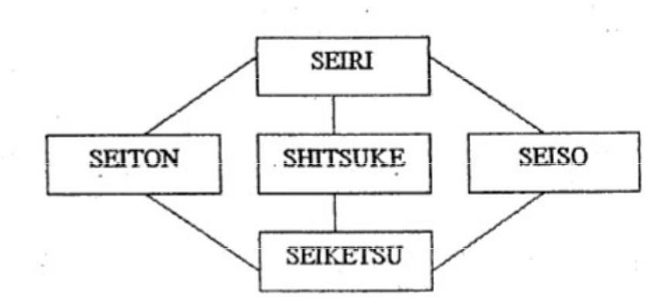

OBJECTIVES OF 5S
- Create a neat and clean work place
- Create systemize day to day working
- Improve work efficiency
- Standardize work practice
- Improve work discipline
- Improve the quality of work and products

FACTORS IN IMPLEMENTING 5S

Participation by all - Should be understood and practiced by all employees
Top management commitment – CEO and Senior management team need personally commitment practice and supervise the program
Should be self sustaining – Banners, slogan posters and new tutors should be fully utilized to draw attention of every one
Review the program – Every month group of people from different areas of responsibilities plan and evaluate each zone

BENEFITS IN IMPLEMENTING 5S
  - Work place becomes proud place to work
  - Results in good image and- generates business
  - Operations become easier and safer in work place
  - Disciplined people
  - Improve productivity' and morality
  - Better quality awareness
  - More usable space
  - Less Material handling time
  - Less production cost
  - Preventive maintenance
  - High employee involvement
  - Less accidents
  - More time to improvement.

SUPPLIER PARTNERSHIP

A commitment to continuous quality improvement cannot be translated into reality without treating supplier as partner
PRINCIPLES OF CUSTOMER / SUPPLIER RELATION
  - Both the customer and the supplier are fully responsible for the control quality

  - Both the customer and the supplier should be independent of each other and respect each other‘s independence

  - The customer is responsible for providing the supplier with clear and sufficient requirements so that the supplier can know precisely what to produce

  - Both the customer and the supplier should enter into an non adversarial contract with respect to quality, quality, price, delivery method and terms of payments

  - The supplier is responsible for providing the quality that will satisfy the customer and submitting necessary data upon the customer‘s request

  - Both the customer and the supplier should decide the methods to evaluate the quality of the product or service to the satisfaction of both parties

  - Both the customer and the supplier should establish in the contract the method by which they can reach an amicable settlement of any disputes that may arise

  - Both the customer and the supplier should continually exchange information, sometimes using multifunctional teams, in order to improve the product or service quality
  - Both the customer and the supplier should perform business activities such as procurement, production and inventory planning, clerical work and system so that an amicable and satisfactory relationship is maintained
  - When dealing with business transactions both the customer and the supplier should always have the best interest of the end user in mind

SUPPLIER PARTNERING

It is defined as a continuing relationship, between a buying firm and supplying firm, involving a commitment over an extended time period, an exchange of information, and acknowledgement of the risks end rewards of the relationship.
BENEFITS OF SUPPLIER PARTNERING
Improved Quality Reduced cost Increased Productivity Increased efficiency Increased market share Increased opportunity for innovation Continuous improvement of products/services. .

JAPANES REVIEW OF PARTNERING
The Japanese partnering concept is KELRESTU – developing long term relationships with a few key suppliers rather than having short term relationship with many suppliers.
Key elements to Partnering Long term Commitment Trust Shared vision - To satisfy the end users is the common goal of both supplier and customer.

SUPPLIER SOURCING
Sole sourcing - only one supplier for the entire organization. This may be forced. to happen because of patent, technical specification, raw material location, monopolistic supplier Multiple sourcing - For a single item having two or more supplier, resulting in better quality, better service at lower cost

UNIT III TQM TOOLS & TECHNIQUES I THE SEVEN TRADITIONAL TOOLS OF QUALITY
- - Pareto chart
- - Flowchart
- - Cause-and-Effect Diagrams
- - Check Sheets V- Histograms
- - Scatter Diagrams
- - Control Charts

Pareto chart:

Italian economist Vilfredo Pareto Shows on a bar graph which factors are more significant. This method helps to find the vital few contributing maximum impact.

Purpose: The purpose of the Pareto chart is to prioritize problems No company has enough resources to tackle every problem, so they must prioritize.

Pareto Principle: The Pareto concept was developed by the describing the frequency distribution of any given characteristic of a population. Also called the 20-80 rule, he determined that a small percentage of any given group (20%) account for a high amount of a certain characteristic (80%).

Conclusion: The most important thing in improving quality is to start somewhere, doing something. As you begin using the Pareto chart to decide where your problems are, you will discover many things about your processes and will come because you will know where to improve.

Flowchart:

A technique that separates data gathered from a variety of sources so that patterns can be seen (some lists replace "stratification" with or "run chart").

Purpose: Flow Charts provide a visual illustration of the sequence of operations required to complete a task.

A picture of the steps the process undergoes to complete it's task. Every process will require input(s) to complete it's task, and will provide output(s) when the task is completed. Flow charts can be drawn in many styles. Flow charts can be used to describe a single process, parts of a process, or a set of processes. There is no right or wrong way to draw a flow chart. The true test of a flow chart is how well those who create and use it can understand it.

Input Process Output

Cause-and-Effect Diagrams

1943 by Mr. Kaoru Ishikawa at the University of Tokyo

Purpose: One important part of process improvement is continuously striving to obtain more information about the process and it's output. Cause-and-effect diagrams allow us to do not just that, but also can lead us to the root cause, or causes, of problems
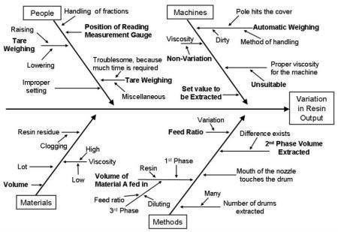

Constructing the Cause-and-Effect Diagram:

Step 1: Select the team members and a leader. Team members knowledgeable about the quality. Team members focus on the problem under investigation.

Step 2: Write the problem statement on the right hand side of the page, and draw a box around it with an arrow running to it. This quality concern is now the effect.

Step 3: Brain-storming. The team members generate ideas as to what is causing the effect. Step 4: This step could be combined with step 3. Identify, for each main cause, its related sub-causes that might affect our quality concern or problem (our Effect). Always check to see if all the factors contributing to the problem have been identified. Start by asking why the problem exists.

Step 5: Focus on one or two causes for which an improvement action(s) can be developed using other quality tools such as Pareto charts, check sheets, and other gathering and analysis tools.

Conclusion: Improvement requires knowledge. The more information we have about our processes the better we are at improving them. Cause-and-effect diagrams are one quality tool that is simple yet very powerful in helping us better understand our processes.

Check Sheets

Purpose: Check sheets allow the user to collect data from a process in an easy, systematic, and organized manner.

Data Collection: Before we can talk about check sheets we need to understand what we mean by data collection. This collected data needs to be accurate and relevant to the quality problem. The first is to establish a purpose for collecting this data. Second, we need to define the type of data that is going to be collected. Measurable data such as length, size, weight, time,...etc., and Countable data such as the number of defects. The third step is to determine who is going to collect that data and when it should be collected.

Histograms

Purpose: To determine the spread or variation of a set of data points in a graphical form. It is always a desire to produce things that are equal to their design values.
Histograms: A histogram is a tool for summarizing, analyzing, and displaying data. It provides the user with a graphical representation of the amount of variation found in a set of data.
Constructing a Histogram: The following are the steps followed in the construction of a histogram:
Data collection: To ensure good results, a minimum of 50 data points, or samples, need to be collected

Calculate the range of the sample data: The range is the difference between the largest and smallest data points. Range = Largest point - smallest point.

Calculate the size of the class interval. The class interval is the width of each class on the X axis. It is calculated by the following formula:

Class interval = Range / Number of classes.

Calculate the number of data points (frequency) that are in each class. A tally sheet is usually used to find the frequency of data points in each interval.

Conclusion: Histogram is simple tools that allow the user to identify and interpret the variation found in a set of data points. It is important to remember that histograms do not give solutions to problems.

Scatter Diagrams

Purpose: To identify correlations that might exist between a quality characteristic and a factor that might be driving it.

Scatter Diagrams: A scatter diagram is a nonmathematical or graphical approach for identifying relationships between a performance measure and factors that might be driving it. This graphical approach is quick, easy to communicate to others, and generally easy to interpret.

Interpreting the Results: Once all the data points have been plotted onto the scatter diagram, you are ready to determine whether their exists a relation between the two selected items or not. When a strong relationship is present, the change in one item will automatically cause a change in the other. If no relationship can be detected, the change in one item will not effect the other item. Their are three basic types of relationships that can be detected to on a scatter diagram: 1. Positive relationship 2. Negative relationship 3. No relationship
Conclusion: Scatter diagrams allow the user to graphically identify correlations that could exist between a quality characteristic and a factor that might be driving it. It is a quality tool that is simple, easy to communicate to others, and generally easy to interpret

Control Charts

Purpose: Process is in control and to monitor process variation on a continuous basis. Identifying the tolerance level in the variations. Control charts is one SPC tool that enables us to monitor and control process variation. Types of variation Common and Special Cause Variation

Control charts: Developed in the mid 1920's by Walter Shewhart of Bell labs. There are two basic types of control charts, the average and range control charts. The first deals with how close the process is to the nominal design value, while the range chart indicates the amount of spread or variability around the nominal design value. A control chart has basically three line: the upper control limit UCL, the center line CL, and the lower control limit LCL. A minimum of 25 points is required for a control chart to be accurate.

NEW MANAGEMENT TOOLS

Seven New Management and Planning Tools In 1976, the Union of Japanese Scientists and Engineers (JUSE) saw the need for tools to promote innovation, communicate information and successfully plan major projects. A team researched and developed the seven new quality control tools, often called the seven management and planning (MP) tools, or simply the seven management tools. Not all the tools were new, but their collection and promotion were. The seven MP tools, listed in an order that moves from abstract analysis to detailed planning, are:

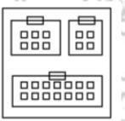
  - Affinity diagram: organizes a large number of ideas into their natural relationships.

  - InterRelations diagram:

Shows cause-and-effect relationships and helps you analyze the natural links between different aspects of a complex situation.
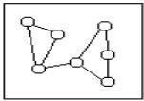

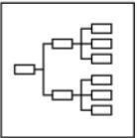
  - Tree diagram: breaks down broad categories into finer and finer levels of detail, helping you move your thinking step by step from generalities to specifics.

  - Matrix diagram: shows the relationship between two, three or four groups of information and can give information about the relationship, such as its strength, the roles played by various individuals, or measurements.

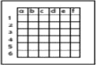

  - Matrix data analysis: a complex mathematical technique for analyzing matrices, often replaced in this list by the similar prioritization matrix. One of the most rigorous, careful and time-consuming of decision-making tools, a prioritization matrix is an L-shaped matrix that uses pair wise comparisons of a list of options to a set of criteria in order to choose the best option(s).
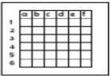

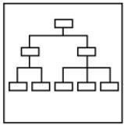
  - Arrow diagram: shows the required order of tasks in a project or process, the best schedule for the entire project, and potential scheduling and resource problems and their solutions

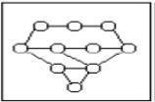
  - Process decision program chart (PDPC): systematically identifies what might go wrong in a plan under development.

SIX SIGMA

Six Sigma has evolved over the last two decades and so has its definition. Six Sigma has literal, conceptual, and practical definitions. Features that set Six Sigma apart from previous quality improvement initiatives include – Clear focus on achieving measurable and quantifiable financial returns from any project.

etc. to lead and implement the Six Sigma approach.

Assumptions and guesswork.
At Motorola University, we think about Six Sigma at three different levels: As a metric
As a methodology
As a management system
Essentially, Six Sigma is all three at the same time.

Six Sigma as a Metric

The term "Sigma" is often used as a scale for levels of "goodness" or quality. Using this scale, "Six Sigma" equates to 3.4 Defects Per Million Opportunities (DPMO). Six Sigma started as a defect reduction effort in manufacturing and then applied to other business processes for the same purpose. Taking the 1.5 sigma shift into account, short-term sigma levels correspond to the following long-term DPMO values (one-sided):
One Sigma = 690,000 DPMO => efficiency 31% Two Sigma = 308,000 DPMO => efficiency 69.2% Three Sigma = 66,800 DPMO => efficiency 93.32% Four Sigma = 6,210 DPMO => efficiency 99.379% Five Sigma = 230 DPMO => efficiency 99.977%
Six Sigma = 3.4 DPMO => efficiency 99.9997%

Six Sigma as a Methodology

As Six Sigma has evolved, there has been less emphasis on the literal definition of 3.4 DPMO, or counting defects in products and processes. Six Sigma is a business improvement methodology that focuses an organization on:

Understanding and managing customer requirements

Aligning key business processes to achieve those requirements Utilizing rigorous data analysis to minimize variation in those processes Driving rapid and sustainable improvement to business processes
At the heart of the methodology is the DMAIC model for process improvement. DMAIC is commonly used by Six Sigma project teams and is an acronym for:
DMAIC - The basic methodology consists of the following five steps:

Define process improvement goals that are consistent with customer demands and the enterprise strategy.
Measure key aspects of the current process and collect relevant data.

Analyze the data to verify cause-and-effect relationships. Determine what the relationships are, and attempt to ensure that all factors have been considered.
Improve or optimize the process based upon data analysis using techniques like Design of Experiments.
Control to ensure that any deviations from target are corrected before they result in defects. Set up pilot runs to establish process capability, move on to production, set up control mechanisms and continuously monitor the process.

DMADV
The basic methodology consists of the following five steps:

Define design goals that are consistent with customer demands and the enterprise strategy.
Measure and identify CTQs (characteristics that are Critical To Quality), product capabilities, production process capability, and risks.
Analyze to develop and design alternatives, create a high-level design and evaluate design capability to select the best design.
Design details, optimize the design, and plan for design verification. This phase may require simulations.
Verify the design, set up pilot runs, implement the production process and hand it over to the process owners.

Implementation roles –

One of the key innovations of Six Sigma is the professionalizing of quality management functions. Prior to Six Sigma, quality management in practice was largely relegated to the production floor and to statisticians in a separate quality

department. Six Sigma borrows martial arts ranking terminology to define a hierarchy (and career path) that cuts across all business functions and a promotion path straight into the executive suite.

BENCHMARKING

"Benchmarking: A continuous, systematic process of evaluating and comparing the capability of one organization with others normally recognized as industry leaders, for insights for optimizing the organizations processes." Benchmarking is the process of comparing the cost, time or quality of what one organization does against what another organization does. The result is often a business case for making changes in order to make improvements. The systematic process of comparing an organization‗s products, services and practices against those of competitor organizations or other industry leaders to determine what it is they do that allows them to achieve high levels of performance. (Society for Human Resources Management)

Advantages of benchmarking

Benchmarking is a powerful management tool because it overcomes "paradigm blindness." Benchmarking opens organizations to new methods, ideas and tools to improve their effectiveness. It helps crack through resistance to change by demonstrating other methods. Allows employees to visualise the improvement which can be a strong motivator for change Helps to identify weak areas and indicates what needs to be done to improve.
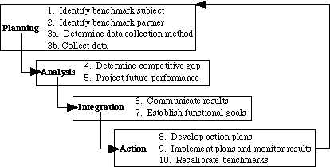

THE BENCHMARKING PROCESS
The formal 10-step benchmarking process is shown in outline below.

- PLANNING.
The essential steps are those of any plan development: what, who and how.

Every function of an organization has or delivers a product or output. Benchmarking is Appropriate for any output of a process or function, whether it‗s a physical good, an order, a Shipment, an invoice, a service or a report.

To whom or what will we compare?
Business-to-business, direct competitors are certainly prime candidates to benchmark. But they are not the only targets. Benchmarking must be conducted against the best companies and business functions regardless of where they exist. How will the data be collected?
There is no one way to conduct benchmarking investigations. There is an infinite variety of ways to obtain required data – and most of the data you will need are readily and publicly available. Recognize that benchmarking is a process not only of deriving quantifiable goals and targets, but more importantly, it is the process of investigating and documenting the best industry practices, which can help you achieve goals and targets.
- ANALYSIS.

The analysis phase must involve a careful understanding of your current process and practices, as well as those of the organizations being benchmarked. What is desired is an understanding of internal performance on which to assess strengths and weaknesses.
- INTEGRATION.

Integration is the process of using benchmark findings to set operational targets for change. It involves careful planning to incorporate new practices in the operation and to ensure benchmark findings are incorporated in all formal planning processes. Steps include:
Gain operational and management acceptance of benchmark findings. Clearly and convincingly demonstrate findings as correct and based on substantive data. Develop action plans.
Communicate findings to all organizational levels to obtain support, commitment and ownership.

- ACTION.
Convert benchmark findings, and operational principles based on them, to specific actions to be taken. Put in place a periodic measurement and assessment of achievement. Use the creative talents of the people who actually perform work tasks to determine how the

findings can be incorporated into the work processes. Any plan for change also should contain milestones for updating the benchmark findings, and an ongoing reporting mechanism. Progress toward benchmark findings must be reported to all employees. 5. Maturity. Maturity will be reached when best industry practices are incorporated in all business processes, thus ensuring superiority. Tests for superiority:
If the now-changed process were to be made available to others, would a knowledgeable businessperson prefer it?
Do other organizations benchmark your internal operations?

Maturity also is achieved when benchmarking becomes an ongoing, essential and self-initiated facet of the management process. Benchmarking becomes institutionalized and is done at all appropriate levels of the organization, not by specialists.

Types of Benchmarking.
Process benchmarking - the initiating firm focuses its observation and investigation of business processes with a goal of identifying and observing the best practices from one or more benchmark firms. Activity analysis will be required where the objective is to benchmark cost and efficiency; increasingly applied to back-office processes where outsourcing may be a consideration.
Financial benchmarking - performing a financial analysis and comparing the results in an effort to assess your overall competitiveness.
Performance benchmarking - allows the initiator firm to assess their competitive position by comparing products and services with those of target firms.
Product benchmarking - the process of designing new products or upgrades to current ones. This process can sometimes involve reverse engineering which is taking apart competitors products to find strengths and weaknesses.
Strategic benchmarking - involves observing how others compete. This type is usually not industry specific meaning it is best to look at other industries.
Functional benchmarking - a company will focus its benchmarking on a single function in order to improve the operation of that particular function. Complex functions such as Human Resources, Finance and Accounting and Information and Communication Technology are unlikely to be directly comparable in cost and efficiency terms and may need to be disaggregated into processes to make valid comparison

Implementation in manufacturing
Poka-yoke can be implemented at any step of a manufacturing process where something can go wrong or an error can be made. For example, a jig that holds pieces for processing might

be modified to only allow pieces to be held in the correct orientation, or a digital counter might track

Yhe number of spot welds on each piece to ensure that the worker executes the correct number of welds.

Shigeo Shingo recognized three types of poka-yoke for detecting and preventing errors in a mass production system:

- The contact method identifies product defects by testing the product's shape, size, color, or other physical attributes.

- The fixed-value (or constant number) method alerts the operator if a certain number of movements are not made.

- The motion-step (or sequence) method determines whether the prescribed steps of the process have been followed.

Either the operator is alerted when a mistake is about to be made, or the poka-yoke device actually prevents the mistake from being made. In Shingo's lexicon, the former implementation would be called a warning poka-yoke, while the latter would be referred to as a control poka-yoke.

FMEA

Failure modes and effects analysis (FMEA) is a procedure for analysis of potential failure modes within a system for the classification by severity or determination of the failures' effect upon the system. It is widely used in the manufacturing industries in various phases of the product life cycle and is now increasingly finding use in the service industry as well. Failure causes are any errors or defects in process, design, or item especially ones that affect the customer, and can be potential or actual. Effects analysis refers to studying the consequences of those failures.

Step 1: Severity

Determine all failure modes based on the functional requirements and their effects. Examples of failure modes are: Electrical short-circuiting, corrosion or deformation. It is important to note that a failure mode in one component can lead to a failure mode in another component. Therefore each failure mode should be listed in technical terms and for function. Hereafter the ultimate effect of each failure mode needs to be considered.

A failure effect is defined as the result of a failure mode on the function of the system as perceived by the user. In this way it is convenient to write these effects down in terms of what the user might see or experience. Examples of failure effects are: degraded performance, noise or even injury to a user.

Each effect is given a severity number(S) from 1(no danger) to 10(important). These numbers help an engineer to prioritize. If the severity of an effect has a number 9 or 10, actions are considered to change the design by eliminating the failure mode, if possible, or protecting the user from the effect. A severity rating of 9 or 10 is generally reserved for those effects which would cause injury to a user or otherwise result in litigation.

Step 2: Occurrence

In this step it is necessary to look at the cause of a failure and how many times it occurs. This can be done by looking at similar products or processes and the failures that have been documented for them. A failure cause is looked upon as a design weakness. All the potential causes for a failure mode should be identified and documented. Again this should be in technical terms. Examples of causes are: erroneous algorithms, excessive voltage or improper operating conditions.
A failure mode is given a probability number (O), again 1-10. Actions need to be determined if the occurrence is high (meaning >4 for non safety failure modes and >1 when the severity-number from step 1 is 9 or 10). This step is called the detailed development section of the FMEA process.

Step 3: Detection

When appropriate actions are determined, it is necessary to test their efficiency. Also design verification is needed. The proper inspection methods need to be chosen. First, an engineer should look at the current controls of the system, that prevent failure modes from occurring or which detect the failure before it reaches the customer.

Hereafter one should identify testing, analysis, monitoring and other techniques that can be or have been used on similar systems to detect failures. From these controls an engineer can learn how likely it is for a failure to be identified or detected. Each combination from the previous 2 steps, receives a detection number(D). This number represents the ability of planned tests and inspections at removing defects or detecting failure modes. After these 3 basic steps, Risk Priority Numbers (RPN) is calculated.
Risk Priority Numbers RPN does not play an important part in the choice of an action against failure modes. They are more threshold values in the evaluation of these actions. After ranking the severity, occurrence and detectability the RPN can be easily calculated by multiplying these 3 numbers: RPN = S x O x D .This has to be done for the entire process and/or design. Once this is done it is easy to determine the areas of greatest concern. The failure modes that have the highest RPN should be given the highest priority for corrective action. This means it is not always the failure modes with the highest severity numbers that should be treated first. There could be less severe failures, but which occur more often and are less detectable.

Uses of FMEA
Development of system requirements that minimize the likelihood of failures. Development of methods to design and test systems to ensure that the failures have been

eliminated. Evaluation of the requirements of the customer to ensure that those do not give rise to potential failures. Identification of certain design characteristics that contribute to failures, and minimize or eliminate those effects. Tracking and managing potential risks in the design. This helps avoid the same failures in future projects. Ensuring that any failure that could occur will not injure the customer or seriously impact a system.

Advantages

- Improve the quality, reliability and safety of a product/process Improve company image and competitiveness

- Increase user satisfaction Reduce system development timing and cost Collect information to reduce future failures

- capture engineering knowledge Reduce the potential for warranty concerns

- Early identification and elimination of potential failure modes Emphasis problem prevention Minimize late changes and associated cost Catalyst for teamwork and idea exchange between functions

Disadvantages

If used as a top-down tool,

FMEA may only identify major failure modes in a system.

Fault tree analysis (FTA) is better suited for "top-down" analysis. When used as a "bottom-up" tool FMEA can augment or complement FTA and identify many more causes and failure modes resulting in top-level symptoms.

It is not able to discover complex failure modes involving multiple failures within a subsystem, or to report expected failure intervals of particular failure modes up to the upper level subsystem or system. Additionally, the multiplication of the severity, occurrence and detection rankings may result in rank reversals,where a less serious failure mode receives a higher RPN than a more serious failure mode. The reason for this is that the rankings are ordinal scale numbers, and multiplication is not a valid operation on them. The ordinal rankings only say that one ranking is better or worse than another, but not by how much. For instance, a ranking of "2" may not be twice as bad as a ranking of "1," or an "8" may not be twice as bad as a "4," but multiplication treats them as though they are.

UNIT IV TQM TOOLS & TECHNIQUES II

BENCHMARKING
Benchmarking is a systematic method by which organizations can measure themselves against the best industry practices.
  - Benchmarking is a systematic search for the best practices, innovative ideas, and highly effective operating procedures.

BENCHMARKING CONCEPT

Creative Adaptation
What are others performance levels ?
How did they get there ?
What is our performance level ?
- How do we do it ?

Breakthrough Performance

REASONS TO BENCHMARK :
  - It is a tool to achieve business and competitive objectives
  - It can inspire managers (and Organizations) to compete
  - It is time and cost effective
  - It constantly scans the external environment to improve the process
  - Potential and useful technological breakthroughs can be located and adopted early

PROCESS OF BENCHMARKING

The following six steps contain the core techniques of Benchmarking

Decide what to benchmark
  - Benchmarking can be applied to any business or production process
  - The strategy is usually expressed in terms of mission and vision statements
  - Best to begin with the mission and critical factors
  - Choosing the scope of the Benchmarking study
  - Pareto analysis – what process to investigate
  - Cause and Effect diagram – for tracing outputs back

Understand current performance

  - Understand and document the current process
  - Those working in the process are the most capable of identifying and correcting problems
  - While documenting, it is important to quantify
  - Care should be taken during accounting information

Plan
  - A benchmarking team should be chosen
  - Organizations to serve as the benchmark need to be identified
  - Time frame should be agreed upon for each of the benchmarking tasks There are three types of benchmarking
    - Internal
    - Competitive
    - Process

Study Others
Benchmarking studies look for two types of information
  - How best the processes are practiced
  - Measurable results of these practices Three techniques for conducting the research are
  - Questionnaires
  - Site visits
  - Focus groups

Learn from the data
Answering a series of questions like
  - Is there a gap between the organization’s performance and the performance of the best-in-class organizations?
  - What is the gap? How much is it?
  - Why is there a gap? What does the best-in-class do differently that is better?
  - If best-in-class practices were adopted, what would be the resulting improvement? Benchmarking studies can reveal three different outcomes
  - Negative gap
  - Parity
  - Positive gap

Using the findings
The objective is to close the gap. For this
  - Findings must be communicated to the people within the organization
  - Action plans must be developed to implement new processes Groups that must agree on the change
  - Process owners
  - Upper management
Steps for the development and execution of action plans are
- Specify tasks
- Sequence tasks
- Determine resources needs
- Establish task schedule
- Assign responsibility for each task

- Describe expected results
- Specify methods for monitoring results

PITFALLS AND CRITICISMS OF BENCHMARKING :
  - Idea of copying others
  - It is not a cure or a business philosophy
  - Some process have to be benchmarked repeatedly
  - It is not a substitute for innovation

QUALITY FUNCTION DEPLOYMENT
  - Quality Function Deployment is a planning tool used to fulfill customer expectations.
  - Quality Function Deployment focuses on customer expectations or requirements, often referred to as voice of the customer.

QFD TEAM :
There are two types of teams namely
- Team for designing a new product
- Team for improving an existing product

BENEFITS OF QFD :
- Improves Customer satisfaction
  - Creates focus on customer requirements
  - Uses competitive information effectively
  - Prioritizes resources
  - Identifies items that can be acted upon

- Reduces Implementation Time
  - Decreases midstream design changes
  - Limits post introduction problems
  - Avoids future development redundancies Promotes Team Work
  - Based on consensus
  - Creates communication
  - Identifies actions

- Provides Documentation
  - Documents rationale for design
  - Adds structure to the information
  - Adapts to changes (a living document)

HOUSE OF QUALITY :

Interrelationship Between
Technical Descriptors

i
Prioritized Customer Requirements
Customer Requirements (Voice of the customer)
Technical Descriptors (Voice of the organization)
Relationship between
Requirements and Descriptors
Priortized Technical Descriptors

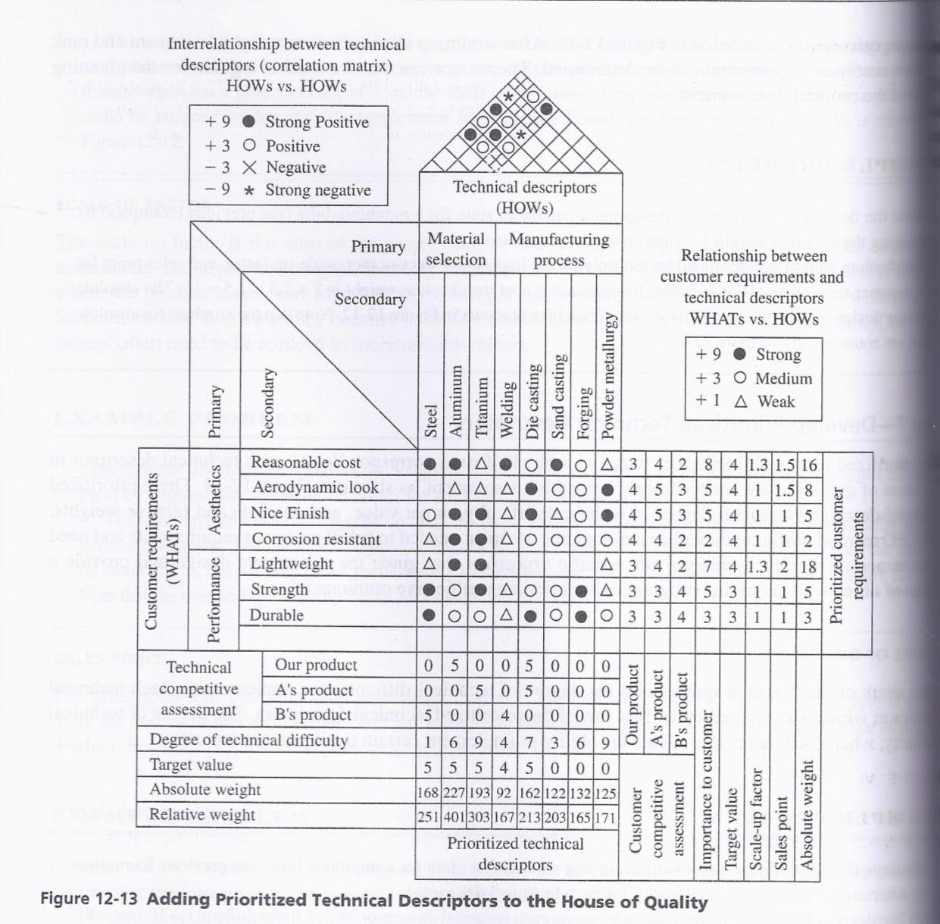

THE STEPS IN BUILDING A HOUSE OF QUALITY ARE :
- List Customer Requirements (WHAT’s)

- List Technical Descriptors (HOW’s)

- Develop a Relationship Matrix Between WHAT’s and HOW’s

- Develop an Inter-relationship Matrix between HOW’s

- Competitive Assessments
  - Customer Competitive Assessments
  - Technical Competitive Assessments

- Develop Prioritized Customer Requirements

- Develop Prioritized Technical Descriptors

TAGUCHI’S QUALITY LOSS FUNCTION

INTRODUCTION
- Taguchi Methods is a statistical methods developed largely by GENICHI TAGUCHI to improve quality of manufactured goods.
- The philosophy of off-line quality control.
- Innovations in the design of experiments.

Taguchi Loss Function Definition
Taguchi defines Quality as “the loss imparted by the product to society from the time the product is shipped.”
LOSS = Cost to operate,
Failure to function, maintenance and repair cost, customer satisfaction, poor design.
Product to be produced “being within specification”

Taguchi’s Vs Traditional Approach Taguchi’s Quadratic Quality Loss Function
Quality Loss Occurs when a product’s deviates from target or nominal value. Deviation Grows, then Loss increases.
Taguchi’s U-shaped loss Function Curve.

Formula to find Taguchi’s Loss Fn

Taguchi uses Quadratic Equation to determine loss Curve
L (x) = k (x-N)²
Where L (x) = Loss Function,
k = C/d² = Constant of proportionality, where C – Loss associated with sp limit

d - Deviation of specification from target value
x = Quality Features of selected product, N = Nominal Value of the product and (x-N) = Tolerance

Problem
A part dimension on a power tool is specified as 32.25±0.25.Company records show±0.25 exceeded & 75% of the returned fo replacement. Cost of replacement is Rs.12,500.Determine k & QLF.

Solution : Expected Cost of repair C = 0.75(12500) = Rs 9,375
k = C/d²= 9375/(90.25)² = Rs 1,50,000 QLF =L (x) 1,50,00(x-N)

Taguchi’s Quality Loss Function concept combines cost, target and variation in one metric with specifications being of secondary importance.
Taguchi has defined quality as the loss imparted to society from the time a product is shipped. Societal losses include failure to meet customer requirements, failure to meet ideal performance and harmful side effects.

- CUSTOMERS PERCEIVE QUALITY AS MEETING THE TARGET RATHER THAN JUST MEETING THE SPECIFICATIONS.

There are three common quality loss functions
  - Nominal - the - best.

  - Smaller - the - better.

  - Larger - the - better.

  - NOMINAL – THE – BEST : Although Taguchi developed so many loss functions, many situations are approximated by the quadratic function which is called the Nominal – the – best type.

L
LSL USL

A
Loss (Rs)

0
τ - ∆ Performance Chaτracteristic
Quadratic Loss Function
Y
τ + ∆

The quadratic function is shown in figure. In this situation, the loss occurs as soon as the performance characteristic, y, departs from the target τ.
At τ, the loss is Rs. 0.
At LSL (or) USL, the loss is Rs. A.
The quadratic loss function is described by the equation L = k (y - τ) ². Where,
L = cost incurred as quality deviates from the target.
y = Performance characteristic
τ = target
k = Quality loss coefficient.
The loss coefficient is determined by setting ∆ = (y – τ), the deviation from the target. When ∆ is the USL (or) LSL, the loss to the customer of repairing (or) discarding the product is Rs. A.

Thus,
K = A / (y – τ)² = A / ∆² .

SMALLER – THE – BETTER :
The following figure shows the smaller – the – better concepts.
The target value for smaller – the – better is 0. There are no negative values for the performance characteristic.
The radiation leakage from a microwave appliance, the response time for a computer, pollution from an automobile, out of round for a hole etc. are the performance characteristics for this concept.

LARGER – THE – BETTER :
The following figure shows the concept of the Larger – the – better.

L

A
Loss (Rs)

y
0 y
Performance Characteristic
Smaller-the-better

TOTAL PRODUCTIVE MAINTENANCE (TPM)

Define TPM(Total Productive Maintenance). Explain in detail TPM steps.
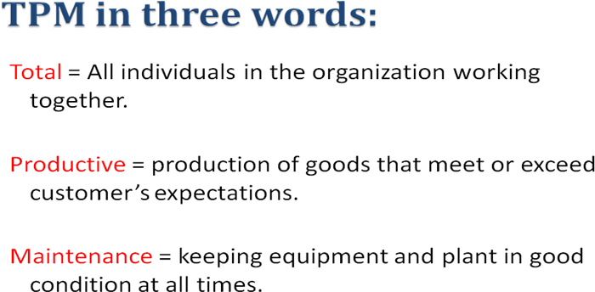

Total Productive Maintenance (TPM) is defined as keeping the running plant and equipment at its highest productive level with the co-operation of all areas of the organization.
Predictive and Preventive maintenance are essential to building a foundation for a successful TPM environment. Predictive Maintenance is the process of using data and statistical

tools to determine when a piece of equipment will fail. Preventive Maintenance is the process of periodically performing activities such as lubrication on the equipment to keep it running.

OBJECTIVES OF TPM :

To maintain and improve equipment capacity.
- To maintain equipment for life.
- To use support from all areas of the operation.
- To encourage input from all employees.
- To use teams for continuous improvement.

TPM PHILOSOPHY – CONCEPT OF TPM :
Total Productive Maintenance (TPM) is an extension of the Total Quality Management (TQM) philosophy to the maintenance function.

TPM has the following steps:
- Management should learn the new philosophy of TPM.
- Management should promote the new philosophy of TPM.
- Training should be funded and developed for everyone in the organization.
- Areas of needed improvement should be identified.
Loss measurements to identify improvement needs are
  - Down time losses
  - Reduced speed losses
  - Poor quality losses

- Performance goals should be formulated.
- An implementation plan should be developed.
- Autonomous worth groups should be established.

FAILURE MODE AND EFFECTS ANALYSIS (FMEA)

What is FMEA?
FMEA is an analytical technique that combines the technology and experience of people in identifying foreseeable failure modes of a product or process and planning for its elimination.
FMEA is a “before-the-event” action requiring a team effort to easily and inexpensively alleviate changes in design and production.
It is a group of activities comprising the following :
  - Recognize the potential failure of a product or process.
  - Identify actions that eliminate / reduce the potential failure.
  - Document the process. Two important types of FMEA are
    - Design FMEA
    - Process FMEA

What are the types of FMEA?
There are several types of FMEA : design FMEA, process FMEA, equipment FMEA, maintenance FMEA, concept FMEA, service FMEA, system FMEA, environmental FMEA, and others.

What Is A Failure Mode?
A Failure Mode is:
- The way in which the component, subassembly, product, input, or process could fail to perform its intended function
  - Failure modes may be the result of upstream operations or may cause downstream operations to fail
- Things that could go wrong

Why

- Methodology that facilitates process improvement
- Identifies and eliminates concerns early in the development of a process or design
- Improve internal and external customer satisfaction
- Focuses on prevention
- FMEA may be a customer requirement
- FMEA may be required by an applicable Quality System Standard

INTENT OF FMEA :
  - Continually measuring the reliability of a machine, product or process.
  - To detect the potential product - related failure mode.
  - FMEA evaluation to be conducted immediately following the design phase.

BENEFITS OF FMEA:
  - Having a systematic review of components failure modes to ensure that any failure produces minimal damage.
  - Determining the effects of any failure on other items.
  - Providing input data for exchange studies.
  - Determining how the high-failure rate components can be adapted to high-reliability components.
  - Eliminating / minimizing the adverse effects that failures could generate.
  - Helping uncover the misjudgements, errors etc.
  - Reduce development time and cost of manufacturing.

Explain the methodology used for FMEA. FMEA Procedure
  - For each process input (start with high value inputs), determine the ways in which the input can go wrong (failure mode)
  - For each failure mode, determine effects
- Select a severity level for each effect
  - Identify potential causes of each failure mode
- Select an occurrence level for each cause
  - List current controls for each cause
- Select a detection level for each cause
  - Calculate the Risk Priority Number (RPN)
  - Develop recommended actions, assign responsible persons, and take actions
- Give priority to high RPNs
- MUST look at severities rated a 10

  - Assign the predicted severity, occurrence, and detection levels and compare RPNs

FMEA Inputs and Outputs
Severity,Occurrence, and Detection
- Severity
  - Importance of the effect on customer requirements
- Occurrence
  - Frequency with which a given cause occurs and creates failure modes
- Detection
  - The ability of the current control scheme to detect or prevent a given cause

Rating Scales
- There are a wide variety of scoring “anchors”, both quantitative or qualitative
- Two types of scales are 1-5 or 1-10
- The 1-5 scale makes it easier for the teams to decide on scores
- The 1-10 scale may allow for better precision in estimates and a wide variation in scores (most common)

Rating Scales
- Severity
- 1 = Not Severe, 10 = Very Severe

Occurrence
- 1 = Not Likely, 10 = Very Likely

Detection
- 1 = Easy to Detect, 10 = Not easy to Detect
- Risk Priority Number (RPN)
- RPN is the product of the severity, occurrence, and detection scores.

Summary An FMEA:
  - Identifies the ways in which a product or process can fail
  - Estimates the risk associated with specific causes
  - Prioritizes the actions that should be taken to reduce risk

Explain with an example Process FMEA document.
The basic philosophy behind process FMEA document is shown in the following document. Process FMEA is an analytical Technique utilized by a manufacturing Responsible Engineering Team as a means to assure that , to the extent possible, potential failure modes and associated causes /mechanisms have been considered and addressed.

FMEA TEAM :
Engineers from- Assembly- Manufacturing- Materials - Quality - Service- Supplier-Customer.

FMEA DOCUMENTATION :
The purpose of FMEA documentation is
- To allow all involved Engineers to have access to others thoughts
- To design and manufacture using these collective thoughts (promotes team approach)

UNIT V – QUALITY SYSTEMS

Overview and evolution of of IS 9000 series of standards .
The International Organization of Standardization (ISO) was founded in 1946 in Geneva, Switzerland. The development of International Standards is to facilitate the exchange of goods and services worldwide. ISO consists of more than 90 country members. The ISO Technical Committee (TC) developed a series of International Standards for Quality Systems, which were first published in 1987. The standards (ISO 9000, 9001, and 9004) were intended to be advisory and developed for use in two-party contractual situations and internal auditing.
These standards were adopted by European Community and have been accepted worldwide with emphasis on quality and economic competitiveness.
The fourth edition of ISO 9001 was released in the year 2008 and it replaces the third edition (ISO9001: 2000), which have been amended to clarify the points in the text and also to enhance the compatibility with ISO 14001: 2004.
Most countries have adopted ISO 9000 series as their national standards.

Fscope and purpose of ISO 9000 Series standards.
The ISO 9000 series Standards is generic in scope. By design, the series can be tailored to fit any organization’s needs. Whether it is large or small, a manufaturerer or a service organization. It can be applied to construction, engineering, health care, legal, and other professional services as well as the manufacturing of anything from nuts and bolts to spacecraft. Its purpose is to unify quality terms and definitions used by industrialized nations and use those terms to demonstrate the supplier’s capability of controlling the processes.
In very simplified terms, the standards require an organization to say what it is doing to ensure quality, then do what it says, and, finally document or prove that it has done what it said.

The ISO 9000 Series of Standards.

ISO 9000: 2005 - Quality Management Systems (QMS)
Fundamentals and Vocabulary discusses the fundamental concepts related to QMS and provides the terminology used in the other two standards.
ISO 9001: 2008 – Quality Management Systems (QMS)
Requirements are the standards used registration by demonstrating conformity of the QMS to customers, regulatory and organization’s own requirements.

ISO 9004 : 2000- Quality Management Systems (qms)
GUIDELINES FOR PERFORMANCE IMPROVEMENT provides guidelines that an organization can use to establish a QMS focused on improving performance.

ISO 9000
ISO 9001
ISO 9002
ISO 9003

ISO 9001
Design, Development, Production, Installation & Servicing
ISO 9002
Production, Installation & Servicing
ISO 9003
Inspection & Testing

ISO 9004
Provides guidelines on the technical, administrative and human factors affecting the product or services.

BENEFITS OF ISO 9000 STANDARDS :
- Achievement of international standard of quality.
- Value for money.
- Customer satisfaction.
- Higher productivity.
- Increased profitability
- Improved corporate image
- Access to global market
- Growth of the organization
- Higher morale of employees

CLAUSES (ELEMENTS) OF ISO 9000 (During the year 1987)
  - Management Responsibility
    - Adequate resources for the verification activities
    - Need for trained personnel
    - Work and verification activities including audits
    - A Management Representative to be identified
    - Review the Quality System performance and customer complaints periodically
  - Quality System
  - Contract review
  - Design Control
  - Documents Control
  - Purchasing
  - Purchaser – Supplied Product
  - Product Identification and Traceability
  - Process Control
  - Inspection and Testing
  - Inspection Measuring and Test Equipment
  - Inspection and Test Status
  - Control of Non – Conforming Product
  - Corrective Action
  - Handling, Storage, Packaging and Delivery

  - Quality Records
  - Internal Quality Audits
  - Training
  - Servicing
  - Statistical Techniques

CLAUSES (ELEMENTS) OF ISO 9000 (During the year 2000)
- Scope
- Normative Reference
- Terms and Definitions
- Quality Management System (QMS)
    - General Requirements
    - Documentation
- Management Responsibility
    - Management Commitment
    - Customer Focus
    - Quality Policy
    - Planning
    - Responsibility, Authority and Communication
    - Management Review
- Resource Management
    - Provision of Resources
    - Human Resources
    - Infrastructure
    - Work Environment
- Product Realization
  - Planning of Product Realization
  - Customer related processes
  - Design and Development
  - Purchasing
    - Production and Service Provision
    - Control of Monitoring and Measuring devices
- Monitoring and Measurement
    - General
    - Monitoring and Measurement
    - Control of Non-Conforming Product
    - Analysis of Data
    - Improvement

IMPLEMENTATION OF QUALITY MANAGEMENT SYSTEM :

- Top Management Commitment
- Appoint the Management Representative

- Awareness
- Appoint an Implementation Team
- Training
- Time Schedule
- Select Element Owners
- Review the Present System
- Write the Documents
- Install the New System
- Internal Audit
- Management Review
- Pre-assessment
- Registration

PITFALLS OF SUCCESSFUL IMPLEMENTATION :
- Using a generic documentation program or another organization’s documentation program
- Over-documentation or documentation that is too complex
- Using External Consultants without involvement
- Neglecting to obtain top management’s involvement
- Developing a system that does not represent what actually occurs

DOCUMENTATION
In every organization, the quality system must be documented properly. The documentation of the system can be seen as a hierarchical format as shown.
1
POLICY

2
PROCEDURE
3
PRACTICE

4
PROOF

Quality Audit
Systematic, independent and documented process for obtaining audit evidence and evaluating it objectively to determine the extent to which audit criteria are fulfilled.

Types of audit
3 types
- Process audits
- Product audits

- System audits

Process audits
- Evaluation of the content and effectiveness of specific processes and work activities
- To confirm the process parameters and improve capability of the process
- To ensure the realization of process quality characteristics
- To ensure improvement of process control during service provision
- Product audits
-To identify opportunities for improvement to establish the quality level of units before final inspection and testing
-To establish the capability of the inspection function
-To determine the usefulness of inspection/tests
- Audits are distinguished by the party requesting:
- 1st party audit (internal audits) – the auditee audits its own quality system according to a quality standard.
- 2nd part audits (supplier audits) – the customer audits the supplier’s quality system
- 3rd party audits – these are external certification audits by an independent institution in order to certify the quality system

Products audits
Investigation of products conformance to specified characteristics
-To obtain additional neutral assessment of product’s level of quality
-To obtain additional assurance that specified quality requirements are met

System audits
- Evaluation all the elements of the quaity system in order to:-
- Verify usefulness, suitability and effectiveness
- Verify adequate documentation
- Verify compliance with requirements
- Determine weak points

Purpose of audits
- Registration / certification audit
- Verify that the organization's QMS meet the requirements of ISO 9001 : 2000

Internal audit
- Identify opportunities for improvement

- Maintain ISO 9001 certification

(2) What are the objevtives of Internal audit? Objectives of the Internal audit
- To verify conformance to applicable standards
- To verify conformance to documented procedures
- To verify effectiveness of the processes in the system
- To identify opportunities to improve the system
- Creating and environment for successful audits (1)

QUALITY AUDITING

The term Audit refers to a regular examination and checking of accounts or financial records, settlement or adjustment of accounts.
It also refers to checking, inspection and examination of Production Processes.

PURPOSE OF QUALITY AUDIT :
- To establish the adequacy of the system.
- To determine the effectiveness of the system.
- To afford opportunities for system analysis.
- To help in problem solving.
- To make decision making easier etc.

TYPES OF QUALITY AUDIT :
- First – Party Audit.
- Second – Party Audit.
- Third – Party Audit.

Quality audit can also be classified on the basis of the area taken into account for the audit such as
  - System Audit.
  - Process Audit.
  - Product Audit.
  - Adequacy Audit.
  - Compliance Audit.

ISO 14000 – ENVIRONMENTAL MANAGEMENT SYSTEM (EMS)
The overall aim of the Environmental Management systems is to provide protection to the environment and to prevent pollution.
    - The success of ISO 9000 along with increased emphasis on Environmental issues was instrumental in ISO’s decision to develop Environmental Management Standards.

    - In 1991, ISO formed the Strategic Advisory Group on the Environment (SAGE) which led to the formation of Technical Committee (TC) 207 in 1992.

    - Mission of TC207 is to develop standards for an Environmental Management System (EMS) which was identified as ISO 14000.

    - TC 207 has Established six sub-committees
      - Environmental Management System (EMS)
      - Environmental Auditing (EA)
      - Environmental labeling (EL)
      - Environmental Performance Evaluation (EPE)
      - Life-Cycle Assessment (LCA)
      - Terms & Definitions

Environmental Management System (EMS) :

EMS has two Evaluation Standards. They are
1. Organization Evaluation Standards 2. Product Evaluation Standards

REQUIREMENT OF ISO 14001
There are six elements
- GENERAL REQUIREMENTS

  - EMS should include policy, planning implementation & operation, checking & corrective action, management review.

- ENVIRONMENTAL POLICY (Should be based on mission)

  - The policy must be relevant to the organization’s nature.
  - Management’s Commitment (for continual improvement & preventing pollution).
  - Should be a framework (for Environmental objectives & Targets).
  - Must be Documented, Implemented, & Maintained.

- PLANNING

  - Environmental Aspects
  - Legal & other Requirements
  - Objectives & Targets
  - Environmental Management Programs

- IMPLEMENTATION & OPERATION

  - Structure & Responsibility
  - Training, Awareness & Competency
  - Communication
  - EMS Documentation
  - Document Control
  - Operational Control
  - Emergency Preparedness & Response

- CHECKING & CORRECTIVE ACTION

  - Monitoring & Measuring
  - Nonconformance & Corrective & Preventive action
  - Records
  - EMS Audit

- MANAGENMENT REVIEW

  - Review of objectives & targets
  - Review of Environmental performance against legal & other requirement
  - Effectiveness of EMS elements
  - Evaluation of the continuation of the policy

ISO 14000: Environmental Standards

ISO 14000

The International Organization for Standards published its Quality Management System (ISO9000) in 1987. ISO9000 became an instant worldwide success.

In 1991, ISO formed Strategic Advisory Group on the Environment (SAGE). The purpose of formation of this group was worldwide increase in emphasis of management of environmental issues a part of quality management systems. This group proposed the formation of Technical Committee to develop standards that deal with environmental management system. This technical committee, TC 207 developed the standards called ISO14000.

The EMS is part of a comprehensive management system that addresses with the overall business activities, including its products and services, affect the environment.

ISO14000SeriesStandards

ISO14000 is a generic standard. When we state the term generic, we mean that- like ISO9000-it is not an industry specific standard.

The series is divided into two separate areas-the organization evaluation standards and the product evaluation standards. The first deals with Environmental Management System (EMS), Environmental Auditing (EA), and Environmental Performance Evaluation (EPE), whereas later deals with Environmental Aspects in Product Standards (EAPS), Environmental Labeling (EL), and Life-Cycle Assessment (LCA).

See following figures to understand the division of standards as mentioned above:

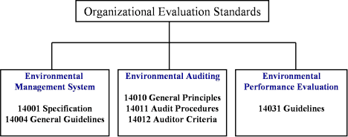

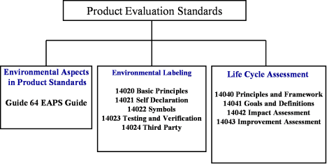

ConceptsofISO 14001:2004Standards

In this post we will particularly discuss ISO 14001:2004 because this standard is the heart of all the environmental standards. This standard provides organizations with the elements of for environmental systems, which can be integrated into other management systems to help achieve environmental and economic goals.

This standard provides guidelines for registration and/or self-declaration of the organization’s environmental management systems. This standard is written in a manner that it can be applicable to all types and sizes of organizations. This standard is also capable to accommodate diverse geographical, cultural, and social conditions.

The demonstration of successful implementation of the system can be used to assure other parties that an appropriate EMS is in place. The basic approach to Environmental System can be understood with the help of following diagram:

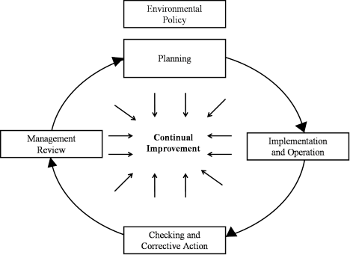

EnvironmentalManagement SystemModel
ISO14001:2004worksas follows:

- As stated earlier in this post that ISO14000 is generic in nature. It does not intend to specify the level of environmental performance of an organization. If that had been the case, ISO would have written it according to the specific activity of each business.
- However, ISO has developed many other environmental standards that deal with specific environmental standards. These standards are beyond the scope of ISO14001:2004 standards at the moment.
- ISO14001:2004 provide a framework to the organizations so that they could communicate about EMS matters with the other stakeholders including customers, environmental regulators, the public and so forth.
- It also provides framework to the organizations-irrespective of their current level of environmental maturity-to remain committed for environmental management and its continual improvement as well.

BENEFITS OF ENVIRONMENTAL MANAGEMENT SYSTEM : GLOBAL BENEFITS
  - Facilitate trade & remove trade barrier
  - Improve environmental performance of planet earth
  - Build consensus that there is a need for environmental management and a common terminology for EMS

ORGANIZATIONAL BENEFITS
  - Assuring customers of a commitment to environmental management
  - Meeting customer requirement
  - Improve public relation
  - Increase investor satisfaction

  - Market share increase
  - Conserving input material & energy
  - Better industry/government relation
  - Low cost insurance, easy attainment of permits & authorization

